

A
Project Report
on

Codex Of Infinity
submitted as partial fulfillment for the award of

BACHELOR OF TECHNOLOGY
DEGREE
SESSION 2025-26
in

CSE-AI&ML
By
Gaurav Rajesh (2200291530043) Aarya Gupta (2300291539001) Aryan Gupta (2200291530025) Ankit Patel (2200291530016)
Under the supervision of
Ms. Umang Kant
KIET Group of Institutions, Ghaziabad

Affiliated to
Dr. A.P.J. Abdul Kalam Technical University, Lucknow
(Formerly UPTU)
May, 2026
DECLARATION

We hereby declare that this submission is our own work and that, to the best of our knowledge and belief, it contains no material previously published or written by another person nor material which to a substantial extent has been accepted for the award of any other degree or diploma of the university or other institute of higher learning, except where due acknowledgment has been made in the text.

Gaurav Rajesh (2200291530043)

Aarya Gupta (2300291539001)

Aryan Gupta (2200291530025)

Ankit Patel (2200291530016)

Date:

Place:



CERTIFICATE

This is to certify that Project Report entitled “Codex Of Infinity" which is submitted by Gaurav Rajesh, Aarya Gupta, Aryan Gupta, Ankit Patel in partial fulfillment of the requirement for the award of degree B. Tech. in the Department of CSE (AI&ML) of Dr. A.P.J. Abdul Kalam Technical University, Lucknow is a record of the candidates own work carried out by them under my supervision. The matter embodied in this report is original and has not been submitted for the award of any other degree.

Ms. Umang Kant Dr. Rekha Kashyap

Professor – CSE(AI) Dean – CSE (AI/AI&ML)

Date:

Place:
ACKNOWLEDGEMENT

It gives us a great sense of pleasure to present the report of the B. Tech Project undertaken during B. Tech. Final Year. We owe special debt of gratitude to Ms. Umang Kant, Department of CSE(AI), KIET, Ghaziabad, for her constant support and guidance throughout the course of our work. Her sincerity, thoroughness and perseverance have been a constant source of inspiration for us. It is only her cognizant efforts that our endeavors have seen the light of the day.
We also take the opportunity to acknowledge the contribution of Dr. Rekha Kashyap, Dean of the Department of Computer Science & Engineering (AI/AIML), KIET, Ghaziabad, for her full support and assistance during the development of the project. We also do not like to miss the opportunity to acknowledge the contribution of all the faculty members of the department for their kind assistance and cooperation during the development of our project.
We also do not like to miss the opportunity to acknowledge the contribution of all faculty members of the department for their kind assistance and cooperation during the development of our project. Last but not the least, we acknowledge our friends for their contribution in the completion of the project.
Gaurav Rajesh (2200291530043)

Aarya Gupta (2300291539001)

Aryan Gupta (2200291530025)

Ankit Patel (2200291530016)
ABSTRACT

With the growing need for programming and problem-solving skills, there has been an increase in the use of online coding sites like LeetCode. These platforms are helpful in enhancing programming skills, but they mostly rely on text-based code solving, which can be hard for novice programmers to comprehend due to a lack of visual interaction and experimentation. Students often find it difficult to understand abstract concepts like algorithms, data structures and control flow purely through code.

This project, Codex of Infinity, seeks to overcome these limitations by exploring a new way to learn programming concepts with an experiential and visual approach. Rather than learning to code, players use a visual programming language system where programming concepts are represented visually. This enables users to see immediate feedback from their actions, simplifying the learning process.

The game is constructed as a learning environment in which the user will navigate through various scenarios, solve logic puzzles and try different approaches to solving problems. Through the use of game elements such as levels, progression and rewards, the system increases user engagement and motivation. The emphasis is on providing users with a hands-on learning experience, rather than rote memorization of syntax and problem repetition.

Codex of Infinity is developed using the Unity game engine, offering a robust platform for interactive and immersive experiences. The system is modular and extensible, and it can be expanded with new concepts, levels and additional features.

This project's outcomes show that visual and experiential learning enhances learning and user experience. Codex of Infinity's approach to linking abstract and practical knowledge provides a new avenue for computer science education.

TABLE OF CONTENTS | Page No.
DECLARATION……………………………………………………………………. | ii
CERTIFICATE……………………………………………………………………… | iii
ACKNOWLEDGEMENT..…………………………………………………………. | iv
ABSTRACT………………………………………………………………………..... | v
TABLE OF CONTENTS…………………………………………………………... | vi
LIST OF ABBREVATIONS…………………………………………………………. | xi
CHAPTER 1 (INTRODUCTION) | 1
1.1. Introduction | 1
1.2. Project Description | 3
1.2.1 Problem Statement | 3
1.2.2 Motivation | 4
1.2.3 Objectives | 5
1.2.4 Why Unity | 6
1.2.5 Scope of the Project | 8
CHAPTER 2 (LITERATURE REVIEW) | 9
2.1. Literature Overview | 9
2.2 Coding Platforms | 10

2.3 Visual / Block - Based Learning Systems | 11
2.4 Game - Based Learning Systems : CodeSpells | 12
2.5 Modern Game Engines : Unity | 13
2.6 GAP Analysis | 14
CHAPTER 3 (PROPOSED METHODOLOGY) | 16
3.1. Overview | 16
3.2. System Architecture | 18
3.3. System Modules | 20
3.3.1. Player Modules | 20
3.3.2. Visual Programming Interface Module | 20
3.3.3. Spell Module | 21
3.3.4 Combat System Module | 21
3.3.5 Game Environment Module | 22
3.3.6 User Interface Module | 22
3.3.7 Feedback and Visualization Module | 22
3.4. Visual Coding System | 23
3.4.1. Block - Based Interface Design | 23
3.4.2. Logic Construction Mechanism | 24
3.4.3. Logic to Gameplay | 24
3.4.4. Real - Time Execution and Feedback | 24
3.4.5 Spell Visualization Area | 25
3.5. Gameplay Mechanics | 25
3.5.1. Character Control | 25
3.5.2. Spell - Based Action System | 26
3.5.3. Combat System | 26
3.5.4. Real - Time Logic Execution | 27

3.5.5. Open - Ended Gameplay | 27
3.5.6. Learning Through Feedback | 27
3.6. Control Flow of the System | 28
3.6.1. Flow of Execution | 28
3.6.2. Flowchart Representation (Conceptual) | 29
3.6.3. Learning Cycle Integration | 30
3.7. Working Of The System | 30
3.7.1.Data Flow Process | 30
3.7.2.Information Flow (Abstract) | 31
3.7.3.Interaction Between Modules | 32
3.7.4.Real-Time Processing | 32
3.8. Tools and Technology used | 33
3.8.1.Game Engine | 33
3.8.2 Programming Language | 33
3.8.3 Visual Coding Framework | 34
3.8.4 Graphics and Asset Design | 34
3.8.5 User interface design tools | 35
3.9. Design Considerations | 35
3.9.1 User experience and Usability | 35
3.9.2 Real-Time Interaction | 35
3.9.3 Flexibility and Creativity | 36
3.9.4 Modularity and Scalability | 36
3.9.5 Performance Optimization | 36
3.9.6 Learning Effectiveness | 37
3.9.7 Error Handling and Feedback | 37
3.10. Limitations Of The System | 37
3.10.1 Simplicity of Visual Code | 37
3.10.2 Restricted Gameplay Scope | 38
3.10.3 Performance Constraints | 38
3.10.4 Training Time | 38
3.10.5 Limited Visualization Features | 39
3.10.6 Dependency on Platform | 39
3.10.7 Single-User System | 39
CHAPTER 4 (RESULTS AND DISCUSSION) | 40
4.1 Overview | 40
4.2 Visual Coding Results | 40
4.3 Discussion | 42
4.4 Future Improvements | 43

CHAPTER 5 (CONCLUSIONS AND FUTURE SCOPE) | 44
5.1. Conclusion | 44
5.2. Future Scope | 46
5.2.1 Enhanced Visual Programming | 46
5.2.2 Improved Gameplay and Levels | 46
5.2.3 Improved Spell Visualization | 46
5.2.4 Multiplayer and Collaborative Learning | 47
5.2.5 Cross-Platform Deployment | 47
5.2.6 Intelligent Assistance System | 47
5.2.7 Enhancements in Performance and Scalability | 47
Final Remark | 47
REFERENCES. | 48
APPENDIX1 | 51
RESEARCH PAPER | 55
PLAGIARISM REPORT | 56

LIST OF ABBREVIATIONS

UI | User Interface
UX | User Experience
AI | Artificial Intelligence
IDE | Integrated Development Environment
API | Application Programming Interface
CPU | Central Processing Unit
GPU | Graphics Processing Unit
FPS | Frames Per Second
OOP | Object-Oriented Programming
2D | Two-Dimensional
3D | Three-Dimensional
VCS | Version Control System
NPC | Non-Player Character
UI Panel | User Interface Panel

CHAPTER 1
INTRODUCTION

Introduction

The ever-evolving world of technology has revolutionised learning and teaching. In computer science, it's essential to learn programming and problem-solving skills. The role of traditional teaching, which is based on the use of textbooks and theoretical concepts, is being replaced by interactive platforms and online coding environments. Online coding platforms like LeetCode have become popular in helping students develop their programming skills by solving problems.

But while these systems are effective, they typically emphasise code writing and execution, which might not work for everyone. Abstract programming concepts can be difficult for beginners to grasp using these systems, as they lack the ability to provide visuals and experience-based learning. For example, it can be difficult to understand the concepts of loops, recursion, data structures and algorithmic flow through text or code alone.

To address these challenges, we need new ways of learning that incorporate visualisation, interaction and experiential learning. According to research in education, the retention of concepts is better achieved by engaging learners in the learning process, rather than just passively presenting the concepts. This has given rise to the concept of gamification of learning, where gamification strategies are used to make learning more interactive and fun.

Codex of Infinity is a project aimed at delivering a new approach to the learning process of programming and problem solving. Rather than focusing solely on the traditional way of coding, the game provides a visual programming environment that allows users to manipulate programming concepts in a more engaging way. The game allows users to interact with programming concepts without having to learn complex syntaxes; instead, they can interact with the visual objects that represent the programming concepts and see the real-time impact on the game.

The vision for this project is for users to learn by doing, rather than rote memorisation or extensive coding. Learners can see how algorithms and logical constructs work in action, helping them gain a deeper understanding of computational concepts. This eliminates the distractions of syntax errors and enables users to concentrate on the logical structures and problem-solving techniques.

The game format in Codex of Infinity provides an interactive lab environment for users to experiment, explore alternatives and receive real-time feedback. This not only improves understanding, but also fosters exploration and a desire to learn, key elements in the learning process.

Additionally, the project employs game design elements like challenges, progression, rewards and narrative to keep students engaged. The integration of gameplay and learning in Codex of Infinity results in an educational and entertaining experience.

This project has been developed using contemporary tools and technologies, such as Unity, which offers a powerful platform for creating interactive and immersive experiences. This approach guarantees scalability, efficiency, and adaptability in creating intricate game and educational features.

Overall, the development of Codex of Infinity marks a transition from traditional text-based programming to an interactive, visual and experience-based method of learning. This project seeks to simplify, enrich and make programming more visual and interactive, particularly for new learners, providing a step towards modern approaches in computer science education.

PROJECT DESCRIPTION

Problem Statement

Even with the plethora of online resources available to learn programming, students face many difficulties:

- Lack of intuitive understanding of abstract concepts

- Reliance on rote learning rather than understanding

- Lack of visualization of algorithm execution

- Lack of engagement due to the format of problem solving

Existing systems like LeetCode concentrate on the final solution being correct and efficient, but not on the evolution process.

So, there is a need for a system that:

- Provides a connection from abstract to concrete knowledge

- Provides real-time visual feedback

- Encourages experimentation and exploration

The Codex of Infinity seeks to address these problems by incorporating gaming elements.

Motivation

The motivation behind the development of Codex of Infinity arises from the limitations observed in traditional methods of learning programming and problem-solving. Most existing platforms, such as LeetCode, focus primarily on writing code to solve predefined problems. While these platforms are effective for practice, they often fail to provide an intuitive and engaging learning experience, especially for beginners.A major challenge in learning programming is the difficulty in understanding how abstract logic translates into real-world behavior. Concepts such as loops, conditions, and control flow are typically learned through syntax and textual outputs, which can be difficult to visualize. This lack of visualization leads to shallow understanding and reduced interest among learners.The idea for this project was also influenced by earlier attempts to integrate programming with gameplay, such as CodeSpells. Although such systems introduced innovative ways of learning, they were limited in scope and are no longer actively developed. This creates an opportunity to design a more advanced, flexible, and modern solution that builds upon these concepts.Codex of Infinity is motivated by the belief that learning should be interactive, creative, and experience-driven. Instead of passively writing code, users should be able to see and feel the effects of their logic in a dynamic environment. By transforming programming constructs into magical spells controlled by the player, the project creates a strong connection between logic and action.Another key motivation is to introduce freedom and creativity into learning. Unlike traditional platforms that have fixed solutions, this system allows players to approach problems in multiple ways. The outcome of each interaction depends entirely on how the player designs and controls their spells, making the experience highly personalized. This reinforces the idea that imagination is the only limit, encouraging experimentation and innovation.Furthermore, integrating combat mechanics—where players use their created spells to fight enemies—adds a sense of purpose and excitement to the learning process. Instead of solving problems in isolation, users apply their logic in real-time scenarios, receiving immediate feedback based on their decisions. This not only improves engagement but also enhances retention of concepts.

Objectives

The major objectives of this project are :

- To design and develop a game where players take on the role of a wizard and use logic-based spells to interact with the environment and enemies
- To implement a visual coding system that allows users to understand programming concepts without focusing on complex syntax
- To provide real-time feedback by showing the direct effects of user-defined logic within the game world
- To transform abstract programming concepts such as loops, conditions, and control flow into interactive gameplay elements

Secondary Objectives :
- To enhance learning through experiential and hands-on interaction rather than passive problem-solving
- To increase user engagement by integrating combat mechanics, where players use their created spells to fight enemies
- To encourage creativity and innovation by allowing multiple approaches to solving challenges, emphasizing that imagination is the only limit
- To reduce the learning curve for beginners by eliminating syntax-related barriers and focusing on logical thinking
- To develop a scalable system that can be expanded with additional levels, concepts, and features in the future

Technical Objectives :
- To build the game using the Unity platform for creating an interactive and visually rich environment
- To design modular and flexible game architecture for easy updates and enhancements
- To ensure smooth gameplay performance and user-friendly interface design

Why Unity?

To create Codex of Infinity, a development environment that allows for real-time interaction, dynamic rendering, and game logic implementation is essential. Unity, a game engine, has been chosen as the main development platform for its capabilities, user-friendliness, and its capacity to build interactive applications.

A crucial aspect of Unity is its support for real-time graphics and physics interactions, which are vital for translating programming concepts into gameplay. Given the project's emphasis on translating logic into spell effects and combat, Unity offers the tools to replicate these interactions.

Additionally, Unity's use of C# scripting enables the implementation of intricate game logic in a modular and organized way. This simplifies the process of creating systems that allow user-defined inputs (visual coding blocks) to be converted into actions such as movement, spell casting, and interacting with enemies.

Unity also provides a very user-friendly editor, facilitating quick development and iteration. Drag-and-drop asset management, scene editing and real-time preview assist in creating and editing game assets. This is a vital feature in a game like Codex of Infinity, where rapid prototyping and iteration are needed.

Unity also allows building interactive user interfaces, an essential feature in the visual coding system. This enables the integration of user interface elements that can visually represent programming constructs like conditions, loops and actions.

Unity also offers cross-platform support. It can run on different platforms like Windows, Android and iOS with minimal code modifications. This allows the game to be released on various platforms in the future.

Unity's community and documentation is also extensive and helps troubleshooting and learning during the development process. Tutorials, assets, and support from the community help streamline development.

Additionally, Unity is efficient in producing immersive environments that are desirable for interactive and fun learning experiences. Unity's strengths in animation, particle effects and visual effects systems are very helpful in creating spell-based gameplay with visually engaging and responsive actions.

Ultimately, Unity is used for this game because it offers a powerful development tool that facilitates interactive gameplay, visualisation of logic, scalability and implementation. Unity's capabilities are well-suited to the goals of Codex of Infinity, making it a perfect fit for creating a game-based learning environment.

Scope of the Project

The goal of Codex of Infinity is to create an interactive gaming platform that allows users to learn programming by visual coding and interactive gameplay. It is about translating logic into gameplay through spells, enabling players to control game interactions and battles according to their own logic.

The platform is targeted at novice users and students who want to learn about programming in an interactive way. It introduces basic concepts like flow control, conditions and logical operators through practical experiences rather than conventional programming.

This project also offers a flexible platform that can be further developed in the future with more levels, more complex programming concepts, and improved gameplay experiences.

CHAPTER 2
LITERATURE REVIEW

Overview

This chapter provides a survey of systems, platforms and approaches of programming and problem-solving learning. The tremendous expansion of computer science education has led to the development of platforms and methods to help students learn programming. These range from conventional coding practice sites, to visual and game-based environments.

Popular coding websites like LeetCode are commonly used to enhance problem-solving abilities and interview preparation. Such platforms teach users to write efficient code and solve algorithmic problems. However, they are often devoid of interactive visualization, which makes it hard for novices to comprehend how algorithms work.

To overcome this, visual programming tools were developed, enabling users to learn concepts visually rather than through text. This makes programming more accessible and easier to learn, but these tools are often limited in functionality and lack immersive and real-world interaction.

Another type of system is the game-based learning system, which combines programming with games. An example of code-based gaming is CodeSpells, where players can cast spells with code. While these systems introduced new concepts, they were small and are no longer being maintained.

Today's development platforms, like Unity, have a great deal of power for generating interactive and immersive environments.

Coding Platforms

Coding platforms have become an essential part of computer science education to practice and improve programming skills and problem-solving ability. LeetCode, HackerRank, and Codeforces, to name a few, have gained traction among students and professional programmers for honing their knowledge of algorithms, data structures, and programming paradigms.

These sites usually offer a range of problems to solve by writing code in a chosen programming language. Users' code is then tested against several test cases to assess its accuracy and performance. This style of practice aids in enhancing problem-solving and critical thinking skills, as well as being used to prepare for coding interviews and programming contests.

Coding platforms offer the benefit of a wide range of problems, from simple to complex. This allows users to work on a wide range of topics including arrays, strings, graphs, dynamic programming and so on. Furthermore, they also provide leaderboards, discussions and solutions to problems.

Nonetheless, for all their merits, there are some drawbacks to using coding platforms, particularly for beginners. Learning is mostly text-based and syntax-oriented, which may be difficult for novice programmers. Students have to spend a lot of time on syntax problems and debugging, rather than on the actual logic.

The other key issue is the absence of visualisation. Very few platforms offer visualisation of the execution of algorithms. Therefore, understanding of concepts like loops, recursion, and operations on data structures are still abstract.

Moreover, these platforms adopt a problem-based approach, where problems are presented with a particular solution in mind. This limits creativity, and does not provide opportunities for experimentation or alternative approaches.

Visual / Block - Based Learning Systems

Block-based or visual learning systems have been developed to make programming easier, particularly for novices. These systems differ from conventional coding environments in that users can develop programs by connecting visual blocks that correspond to various programming elements like loops, conditions, variables and functions. This eliminates the need to memorize intricate syntax rules and minimises errors, allowing beginners to grasp basic programming concepts.

A prime example of this type of system is Scratch, which offers a drag-and-drop programming environment. With it, one can build animations, games and interactive narratives using a logical connection of blocks. The graphical environment of these systems helps users understand the relationships between various parts of a program, enhancing their comprehension.

The major benefit of block-based learning systems is their user-friendliness. They eliminate syntax issues so users can focus solely on problem solving and logical reasoning. They are well-suited for teaching programming to school students and beginners, who may be intimidated by traditional programming.

Moreover, they encourage a visual and interactive learning environment, allowing users to see the effects of their actions. This helps in learning and retains user interest.

But while visual programming systems offer many benefits, they are also not without drawbacks. One issue is scalability. As tasks become more complex, block-based programming can become unwieldy and less efficient than traditional textual programming.

Another drawback is the lack of immersion and real-world application. Although these systems are great for understanding fundamental ideas, they do not offer an interactive and immersive environment where a user can apply their logic in a real-world context. They typically offer only basic interactions, such as simple animations.

Moreover, these systems often do not include other aspects such as strategy, time constraints and problem solving, which are essential for more advanced programming skills.

Game - Based Learning System : CODESPELLS

Education through gaming is an emerging trend in the teaching of programming concepts through gameplay. CodeSpells is a game that enables players to program spells to control the game world.

In this game, the player takes on the identity of a wizard and uses programming elements to control character movement, object interactions and casting spells. This combination allows for a novel learning environment where programming skills are applied to game play and the user can see the direct effect of their code. This game successfully integrates coding with exploration and creativity, which is more engaging than other coding platforms.

A major feature of CodeSpells is that it offers an immersive learning environment. Rather than abstract problem solving, students learn through trial and error, and are encouraged to explore different possibilities. This assists in better understanding the concepts and promotes exploration.

But despite being innovative, CodeSpells has some shortcomings. It is no longer being maintained and is considered abandoned, limiting its accessibility and development. Another weakness is its flexibility and scalability, as it does not support all of the latest game mechanics and learning features.

It also lacks creative possibilities. Although it offers code-based interaction, the possibilities are limited compared to today's development environments and more flexible systems.

Additionally, the absence of ongoing support and development means that the system can't keep up with current educational trends and technologies. This limits its value over the long term.

To summarise, CodeSpells provided a significant idea of blending game and programming, but the limitations and lack of support demonstrate that a more flexible and interactive system is required. Drawing from this concept, Codex of Infinity will build on this system and offer more flexibility, interactivity, up-to-date tools and a more immersive learning environment.

Modern Game Engines : UNITY

The advent of game engines has revolutionised the creation of interactive and learning applications through the ability to simulate and visualise in real-time. One of the most popular engines for designing interactive and immersive experiences is Unity.

Unity allows developers to create systems where users can interact with the environment and actions can be simulated in real-time, making it an ideal platform for interactive learning with visual feedback. For programming education, this feature enables abstract programming concepts like control flow, conditions and algorithms to be represented visually and interactively.

A key strength of Unity is its real-time rendering and physics capabilities, which enable the creation of environments where user interactions and actions are immediately visible. This is especially valuable in games like Codex of Infinity, where programming concepts are translated into spells and battle systems.

Another key feature of Unity is its support for scripting with C#, which allows for advanced behaviors and systems to be created. This allows for the creation of modular systems where user-authored logic can be used to control game actions, increasing functionality and flexibility.

Unity also offers powerful tools for designing interactive user interfaces and effects, crucial for immersive learning experiences. Animations, particle effects and interactive user interface elements enhance user experience.

Additionally, Unity has cross-platform capabilities, enabling the application to run on various platforms like mobile devices and desktops. This enhances accessibility and allows the system to be accessible to a wider user base.

To sum up, the game engines of modern times, such as Unity, offer the features and flexibility to surpass the shortcomings of the previous systems. With the ability to provide real-time interaction, visualisation, and scalability, Unity is a key tool in the development of sophisticated educational systems like Codex of Infinity.

GAP Analysis

This research on existing systems highlights that there has been a great deal of advancement in the field of programming education with coding platforms, visual learning platforms and games. But each of these systems has its own shortcomings, leaving a gap still unfulfilled.

Conventional coding systems, like LeetCode, are typically aimed at problem solving through text programming. This is good to build up problem-solving and programming skills but lacks visualisation and interactivity, so it can be hard for novices to view the inner workings of an algorithm.

Alternatively, block or visual-based platforms such as Scratch make learning easier by eliminating syntax-related issues. But these systems are often shallow and lack complex problem-solving scenarios or immersive environments, and their usage is also limited to simple concepts.

Programming-based games, like CodeSpells, brought the concept of gaming in programming. Such systems showed the effectiveness of experiential learning, giving users the opportunity to play with code in a live environment. But because of factors such as being discontinued, not scalable, and not flexible, they don't entirely address the needs of today's learners.

Therefore, there is a need for a balance between:

- Syntax-based learning systems which prioritise correctness but lack interaction
- Visual systems that explain but could go deeper and into the real world
- Interactive systems that add interactivity but lack freedom and scalability

We need a system that has:

- Visual representation of logic
- Real-time interaction and feedback
- Open-ended problem-solving
- Engaging gameplay with meaningful objectives
Our project, Codex of Infinity, aims to address this by combining all these features. It offers a wizard-themed game environment in which users design and manipulate spells based on logical constructs, and see the immediate effects of their actions, including in combat.

With this system, players can:

- Discover solutions through experimentation
- Explore various approaches rather than single solutions
- Gain deeper conceptual insights through interaction and visualisation

By building on the best of what's out there while avoiding their shortcomings, Codex of Infinity offers a holistic, adaptable, and fun learning environment that meets 21st-century demand.

CHAPTER 3
PROPOSED METHODOLOGY

Overview

This chapter outlines the suggested approach for the design and development of the system, Codex of Infinity, an interactive game-based learning system. The system design methodology is based on the integration of programming concepts with interactive gameplay, so the user can learn by doing as opposed to the conventional text-based methods of programming.

The design of the system is based on a wizard-like gameplay, in which the user defines and manages spells through logical structures. The constructs are based on the principles of programming, such as conditions, sequences and control flow. The player's logic is interpreted and applied in the game as a series of actions, enabling them to see the result of their choices in a real-time context.

The system is developed using the Unity platform that supports real-time rendering, physics-based interactions and interactive user interfaces. The design methodology is based on a modular approach, where the system's components, such as the visual programming system, game mechanics, combat system and user interface are built separately and linked together to achieve optimal performance and scalability.

The methodology also focuses on the use of experiential learning, in which individuals learn by doing, getting feedback and improving their performance. It adopts the process of input, process, execution and feedback, which promotes learning and experimentation.

This chapter also describes the system design, module design, visual programming system, gameplay and data flow of the system. It also discusses the design principles and technologies employed to make the system adaptive and easy to use, and to facilitate innovative problem-solving.

In summary, the proposed approach is to provide an interactive, engaging and user-centred learning environment, where players can learn programming through their imagination, experimentation and application.

System Architecture

The Codex of Infinity system architecture aims to create an interactive, scalable and modular game-based system. It is organised in a manner that the various components of the system cooperate to convert the user-defined game logic into in-game actions.

Broadly, the system can be described as being based on the Input-Process-Output model. Input is given by the player in the form of logic through the visual coding editor. The system processes and translates the logic and generates actions. This is represented as real-time casting, movement and combat interactions in the game world.

1. Input Layer

The input layer is designed to accept user input and logical commands. For this system, players interact with a visual programming environment to design spells based on conditions, sequences and actions. This layer will organise the user inputs in a way that is suitable for the processing system.

2. Processing Layer

The processing layer is at the heart of the system. This converts the abstract logical structures to commands. This layer includes:

- Logic interpretation system
- Spell generation mechanism
- Decision-making algorithms

The processing unit ensures that the logic is properly translated into game actions such as movement, attack, object/object or enemy interactions.

3. Execution Layer

After the logic has been processed, the execution layer takes the appropriate actions in the game. This includes:

- Spell casting
- Character movement
- Interaction with environment

The action layer ensures that all actions are processed in real time.

4. Feedback Layer

The feedback layer is responsible for the user's visual and interactive feedback. It displays the outcomes of the logic using animations, effects and game outcomes. This instant feedback allows users to understand if their logic is right and to experiment and learn.

5. System Components Integration

Our system is a combination of:

- Player (Wizard) System
- Visual Coding Interface
- Combat System
- User Interface

The system modules are designed to be independent and interact in a standardised way to allow flexibility and scalability.

6. Technology Support

The system is based on the Unity platform that supports real-time graphics, physics and interactive user interface elements. Unity provides a platform for communication between different components of the architecture and optimised performance.

7. Data Flow

The system's data flow is:

Interaction → Processing → Action → Feedback

This loop is the basis for the learning system, enabling users to learn through exploration and experimentation.

System Modules

The system design of Codex of Infinity is broken down into several modules for modularity, scalability and ease of implementation. Each module is designed to perform a particular task and all modules work together to create a dynamic interactive experience.

3.3.1 Player (Wizard) Module

The Player Module is the user's character - the wizard. This module handles:

Movement and navigation
Interaction with the environment
Performing user-defined spells

It serves as the main actor through which actions are taken, and is therefore a key element of the system.

3.3.2 Visual Programming Interface Module

This module is the user's interface for creating spells using logical structures. Users specify actions using a formal visual language, rather than code.

It includes:

- Visual representation of logic constructs (e.g. conditions, sequences)
- Easy-to-use interface to create spells
- Input validation and structuring

This is an essential module as it translates user input into system output.

3.3.3 Spell Module (for creating and executing spells)

The Spell Module translates the user's logic into action. It translates the logical structures into spell actions.

Functions include:

- Converts logic to actions
- Handling spell characteristics (type, effect, duration)
- Triggering execution during gameplay

This is the heart of the system and links programming to the game.

3.3.4 Combat System Module

The Combat Module handles actions between the player and enemies. It uses spells that the player has built to attack, defend or control enemies.

It handles:

- Damage calculation
- Collision detection
- Health management
Combat outcomes

This module provides purpose and interactivity to learning.

3.3.5 Game Environment Module

This module describes the overall game environment, terrain, objects and interactants.

Functions include:

- Scene management
- Environmental interactions
- Object behavior

It sets the pace of the game.

3.3.6 User Interface (UI/UX) Module

The UI/UX Module facilitates interaction between the player and the system. It includes:

- Visual coding interface
- Health indicators and game stats
- Menus and navigation controls

This module improves the user interface and experience.

3.3.7 Feedback and Visualisation Module

This module is used to provide feedback to the player in the form of a visualisation of the result of logic.

It includes:

- Visual effects for spells
- Animation responses
- Success/failure indication

This is critical for learning by doing so that the user can see the effects of their logic.

Visual Coding System

The Codex of Infinity Visual Coding System is built upon an interactive, block-based interface for visually building logical programs. The system is designed based on block-based programming models, in which users specify program logic by connecting pre-defined blocks, rather than writing code.

It has two main areas: the logic panel (on the left) and the execution/visualisation panel (on the right).

3.4.1 Block-Based Interface Design

The left side of the interface consists of blocks grouped by type for various programming elements such as:

Event Blocks:
Controls when the program runs (e.g., When clicked, Key pressed)
Motion Blocks:
Represent motion-related actions like move or turn
Control Blocks:
Denote logical structures like if-then, repeat forever, if-else
Operator Blocks:
Used to create conditions and logical statements

They are visually differentiated and they can be dragged and connected to produce a flow of instruction. This eliminates the need to worry about syntax, enabling users to think purely in terms of logic.

3.4.2 Logic Construction Mechanism

A spell is constructed using blocks of logical structure. For instance, with the interface:

- The program starts with an event block (When clicked)
- A loop block (Repeat forever) runs forever
- A conditional statement (If-Else) is used
- Within the structure, action blocks specify movement and rotation

This structure mirrors actual programming logic, where control flow defines the order of execution.

3.4.3 Logic to Gameplay

The sequence of blocks is interpreted by the system and translated into gameplay. Each block has a particular function:

Movement blocks → Character navigation
Rotation blocks → Direction control
Condition blocks → Decision-making behaviour
Loop blocks → Ongoing or repeating actions

This ensures that all user-constructed logic has an impact on the gameplay.

3.4.4 Real-Time Execution and Feedback

The created logic is executed in real time in the game environment. While the player performs the program:

- The wizard takes actions according to the logic
- Dynamic rotations and movements take place
- The wizard can act conditionally

This provides instant feedback of how their code is interpreted in practice.

3.4.5 Spell Visualisation Area (Future Enhancement)

The right-hand side of the interface is intended to be a visualisation area, where the effects of spells can be shown and gameplay results visualised.

This space can be used to:

Visualise the effects of the spell being cast
Show attack animations
Show interaction with enemies

Gameplay Mechanics

Codex of Infinity’s gameplay mechanics aim to combine programming logic with interactive gameplay and combat. The engine turns player-generated logic into live actions, enabling them to play a wizard character and interact with the game environment with spells programmed using the visual programming system.

The gameplay is premised on the idea that the player's logic drives the game, and each interaction is different, depending on creativity and problem-solving skills.

3.5.1 Character Control

The player takes on the role of a wizard in a game world. Actions and movement are not simply controlled by keyboard or other input devices but are heavily reliant on the logic developed in the visual programming language.

Basic mechanics include:

- Movement in the game environment
- Rotation and directional control
- Interaction with objects and enemies

These are done according to the player's logical design.

3.5.2 Spell-Based Action System

The main gameplay is based on the player's spells. This is a series of logical rules that dictate the player's behaviour in various circumstances.

For example:

A spell can make the player move towards an enemy
A spell can attack if certain conditions are met
A spell can loop to perform an action

This results in gameplay not being pre-programmed, but determined by the player.

3.5.3 Combat System

The combat system provides interaction with enemy objects. The player turns to his or her spells to attack, defend or evade.

Key elements include:

- Health and damage system
- Collision of spells and enemies
- Timing and execution of actions
- Strategy based on logic design

The main platform used for experimentation in logic is combat.

3.5.4 Real-Time Logic Execution

Every action in the game is real-time interpreted from the player’s logic. Once a spell is cast:

- The system interprets the logic
- Performs actions continuously or conditionally
- Updates behavior dynamically

This instant execution offers instant feedback and learning.

3.5.5 Open-ended Gameplay

One of the gameplay mechanics is total freedom. There's no one way to approach a problem or enemy.

Players can:

- Design multiple strategies
- Try various logic structures
- Create unique spell combinations

This embodies the message that "the only limit is your imagination", promoting creativity and experimentation.

3.5.6 Learning through Feedback

The game employs an iterative learning process:

- Player creates logic (spell)
- Spell is executed in the game
- Result is determined (success/failure)
- Player modifies logic

Control Flow Of The System

Codex of Infinity's control flow is the sequence of operations that translates user-specified logic into real-time gameplay. It outlines the process through which player input is interpreted, executed and rendered visual feedback in the gaming environment.

The system is driven by a sequence of actions that enables seamless interaction between its components, and a feedback loop of learning.

3.6.1 Flow of Execution

The system has the following flow of control:

Start / Initialization
The game is set up, and all the system components such as player, user interface (UI) and enemy are loaded.
User Input (Spell Creation)
The user designs a spell logic in the visual programming environment by placing logical blocks like conditions, loops and actions.
Input Validation
The system validates if the created logic is correct and well-formed.
Logic Processing
The system then processes and compiles the logic into instructions.
Spell Execution
The interpreted logic is applied in the game world, resulting in actions like moving, attacking or rotating.
Game Interaction
These actions have consequences with the game environment and enemies, such as damage, physics, or collisions.
Feedback Generation
Instant feedback is given in the form of animations, effects, or other gameplay feedback.
Condition Check / Loop Continuation
If there are loops or conditions, the system continues the loop or branches to another condition (e.g., loop forever, if this, do that).
User Modification
The player can alter the logic based on the feedback, in order to enhance strategy or performance.
End / Continue Cycle
This cycle continues, creating an interaction and learning loop.

3.6.2 Flowchart Representation (Conceptual)

Start
↓
Initialize System
↓
User Writes Spell (Visual Programming)
↓
Validate Input
↓
Process Logic
↓
Execute Spell
↓
Interact with Environment & Enemies
↓
Create Feedback (Visual & Play)
↓
Check Conditions / Loop
↓
Modify Logic (if needed)
↓
Repeat / Continue Gameplay

3.6.3 Learning Cycle Integration

The control flow is related to an experiential learning cycle in which:

- Action → Cast spell
- Feedback → Visual/game response
- Improvement → Logic modification

The above cycle helps users to learn from their actions.

Working Of The System

Codex of Infinity's data flow illustrates how data is transmitted between various components of the system from user input to gameplay result. It demonstrates how the logical statements defined by the user are interpreted, executed and translated into real-time gameplay.

The system operates according to a well-defined pipeline for communication between different stages of the system and execution of logic defined by the user.

3.7.1 Data Flow Process

The system's data flow process can be broken down into:

Input (Visual Coding)
The player designs spells in the visual coding system, by placing logical blocks like events, conditions, loops and actions. The input is the data of the system.
Input Structuring and Storage
The program converts the user-defined blocks into a structured representation (e.g. tree, sequence) that represents the order of the spell.
Logic Processing Unit
The formatted input is then fed into the processing unit, which translates the input into commands. Here, visual representations are converted to system commands.
The translated instructions are run in the game. The system performs actions like movement, casting spells and interacting with game objects and enemies.
Game State Update
The engine modifies the state of the game according to the actions. This may involve the player's location, enemy health, game environment, and so on.
Feedback Generation
The new game state is visualized via animations, effects and user interface. This offers feedback to the player.
User Observation and Adjustment
The player makes adjustments based on the outcome and repeats the process.

3.7.2 Information Flow (Abstract)

User Input (Blocks)
↓
Structured Logic (Tree/Sequence)
↓
Logic Processing Unit
↓
Execution Engine
↓
Game State Update
↓
Visual Feedback (Effects/UI)
↓
User Adjustment
↓
Repeat Cycle

3.7.3 Interaction Between Modules

The flow of data guarantees interaction between the modules:

Visual Coding Module → Processing Module:
Compiles user's logic
Processing Module → Execution Engine:
Sends executable instructions
Execution Engine → Game Modules:
Manages the state of players, enemies and environment
Game Modules → UI/Feedback Module:
Displays information to the user

The flow between these components ensures they are all in sync.

3.7.4 Real-Time Processing

Data processing is done in real time, so that:

- User actions are handled immediately
- Commands are carried out instantly
- Feedback is provided immediately

This data processing is crucial in creating immersion and enabling experiential learning.

Tools and Technology used

Codex of Infinity is developed using a range of tools and technologies to enable efficient development, interactive design and gameplay performance. These tools cover various system development areas, such as game development, scripting, design and interaction.

3.8.1 Game Engine

The main tool used for development is Unity.
The Unity game engine is a development environment for creating interactive content, commonly used in game development.

Key features utilized:

- Real-time rendering and physics engine
- Scene management and object handling
- Animation and particle effects
- Integration of user interface components

The Unity system allows for dynamic gameplay where user-provided scripts are run-time evaluated.

3.8.2 Programming Language

Unity is programmed in C#, the default scripting language for Unity.

How C# is used in the project:

- Implementing game logic and mechanics
- Managing user input and interactions
- Controlling the execution of spells
3.8.3 Visual Coding Framework

A custom visual coding system is created for the project. This system:

- Visually represents programming constructs as blocks
- Translates the user's logic into code
- Removes syntax barriers for novices

This is a major component of attaining experiential learning.

3.8.4 Graphics and Asset Design

Game asset and graphics design is undertaken with tools like Blender.

Applications include:

- Creating 3D models (characters, background)
- Creating animations and visual effects
- Improving the look and feel of the game

3.8.5 User interface design tools

Unity’s UI system is used to design:

- Visual coding interface
- Game menus and controls
- Feedback and display elements

Design Considerations

Codex of Infinity is designed with a number of considerations in mind to ensure it is effective, usable and scalable. The project seeks to integrate learning and play, so the system is developed considering both the educational and technical factors.

3.9.1 User experience and Usability
A crucial aspect is to ensure the system is usable, particularly for novice users. The visual coding environment is designed to:
- Eliminate complex syntax
- Be well-organised and straightforward
- Allow easy creation and modification of logic

3.9.2 Real-Time Interaction
The system provides instantaneous feedback to the user. This ensures that:
- Users can see the outcomes of their reasoning
- Mistakes can be quickly corrected
- Engagement is maintained throughout the gameplay
- Instantaneous execution is required for a learning experience.

3.9.3 Flexibility and Creativity
Users can solve problems in a number of ways. There's no single answer for problems in gameplay, which allows:
- Creative thinking
- Exploration of various logic structures
- Personalized learning experiences

3.9.4 Modularity and Scalability
The system is built following a modular approach, where the visual coding system, gameplay and the user interface are built separately.
This ensures:
- Easy maintenance and debugging
- Easy addition of new features or modules
- Potential for further improvements

3.9.5 Performance Optimization
The system is running and rendering in real-time and performance plays a critical role. The design ensures:
- Smooth execution of user code
- Smooth gameplay without lag
- Optimized resource usage

3.9.6 Learning Effectiveness
The system is developed according to the principles of experiential learning, which means:
- Participants learn through experience
- Learning is reinforced by repetition
- Visualization leads to better understanding

3.9.7 Error Handling and Feedback
Appropriate error handling is provided so that:
- Logic structure is invalid
- Users are given feedback on errors
- The system is stable when executed

This aids learning and development of logic.

Limitations Of The System

Although Codex of Infinity offers a unique interactive learning experience for programming concepts, there are some areas that can be improved in future versions.

3.10.1 Simplicity of Visual Code

The existing visual coding system is limited to simple programming concepts like conditions, loops and basic actions.

Data structures, recursion and complex algorithms are not well supported
It can be complex to manage large blocks

3.10.2 Restricted Gameplay Scope

The game features only simple movement and combat interactions.

- Limited set of enemies and environments
- There are no advanced gameplay elements such as multiplayer or complex world

3.10.3 Performance Constraints

Because actions and logic are executed in real time, performance can be impacted in situations where:

- Complex logic structures are created
- Multiple actions are executed simultaneously

Optimization is needed to manage high volume interactions.

3.10.4 Training Time

While the system eliminates syntax, users may still need to:

- Understand how logical blocks interact
- Design effective spell structures

This can be alleviated through effective tutorials and guidance.

3.10.5 Limited Visualization Features

The current version offers some visual feedback.

- Complex spells and effects are in development
- The right-hand side panel is in work

3.10.6 Dependency on Platform

The system is developed with the Unity engine, which can lead to:

- Platform-specific limitations
- Limited compatibility with system and hardware resources

3.10.7 Single-User System

The release version supports single-player mode.

- Lack of support for multiplayer or social learning
- Limited social interaction within the system.

CHAPTER 4
RESULTS AND DISCUSSION

Overview

The aim of this chapter is to report the outcomes of the implementation of Codex of Infinity and their implications for learning programming concepts. The system is assessed on its capacity to translate user's logic into in-game actions and offer an interactive learning environment.

The findings are centred on the performance of the visual programming system, the gameplay mechanics and user interaction with the system. A range of scenarios are explored to represent the effects of user-defined logical expressions on gameplay.

The discussion also identifies the system's advantages, how it compares to other systems, and its role in supporting experiential learning. It also discusses the limitations and potential improvements to support future work.

Visual Coding Results

The visual coding system shows the effective translation of logical structures to gameplay actions. The user can define structure in terms of blocks for events, conditions, loops and actions.

Once a user specifies a block structure, the coding system translates the structure into an action that is executed. For example:

- Event blocks trigger execution
- Control blocks control repetition and decision-making
- Action blocks specify character actions (e.g. movement, rotation)

Our findings indicate users can quickly build logic without worrying about syntax, which makes the system very user-friendly. The blocks are executed and have an impact on the wizard in the game, which creates a link between cause and effect.

The logic blocks allow users to visually comprehend the execution flow and immediate feedback helps in troubleshooting and developing solutions. This indicates the system successfully facilitates visual and interactive learning.

Discussion

The findings show that the Codex of Infinity has achieved a combination of code and gameplay in a way that allows for a more immersive learning experience. The proposed system offers a visual and interactive learning experience, in contrast to traditional platforms like LeetCode, which emphasise syntax-based problem solving.

The system provides a more interactive environment than visual platforms such as Scratch, by incorporating gaming and interaction. Participants can test their logic in combat simulations, rather than just creating animations.

A major advantage of the system is that it provides instant feedback to users about the results of their logic. This promotes learning and experimentation.

Further, the system encourages creativity in problem-solving, as there is no one answer. Learners can devise several strategies based on their creativity, which enhances the learning experience.

Overall, the findings suggest that the system enhances conceptual learning, engagement and offers a practical learning approach for programming concepts.

Future Improvements

The system is promising, but there are a number of improvements that can be made to enhance its use and efficiency:

Advanced Spell Visualization:
The details panel can be extended to show more about the effects and animations of spells.
Expanded Visual Coding System:
Addition of more sophisticated programming concepts like functions, variables and data structures.
Enhanced Gameplay Features:
Addition of a variety of enemies, levels and challenges to improve engagement.
Multiplayer and Collaboration:
Allowing users to engage and learn with others.
Improved AI System:
Smarter and responsive enemy AI to provide challenging gameplay.
Performance Optimization:
Greater system speed to process complex conditions and a larger game world.

CHAPTER 5
CONCLUSION AND FUTURE SCOPE

Conclusion

The Codex of Infinity project is a successful implementation of a new way to learn programming concepts in a gaming environment. The project combines logic skills and real-time gameplay through the creation and execution of spells in a visual coding environment.

This project emphasises experiential learning rather than syntax and standardised problem-solving approaches, which are the main focus of existing coding websites like LeetCode. By providing a direct correlation between the outcome of a user's logic and the effect it has in the game, the user can grasp the concept of programming. This makes it easier for novices to get started and improves their understanding.

The use of block-based visual programming facilitates the creation of logical structures with visual components. These structures are then mapped to real-time gameplay functions such as movement, casting spells and combat. The inclusion of game elements, such as interacting with enemies and combat, provides motivation and engagement.

Our findings demonstrate that the system:

- Improves the learning of programming concepts
- Promotes reasoning and problem solving
- Offers instant feedback on actions
- Encourages inventive and versatile thinking

The system is based on a modular architecture, enabling future upgrades and improvements. In conclusion, Codex of Infinity offers a practical and effective alternative to other forms of learning, and showcases the benefits of interactive learning through gaming.

Future Scope

Although the current version of Codex of Infinity is an effective learning environment, there are several areas for further development:

5.2.1 Enhanced Visual Programming

Improvement of some advanced program constructs such as:
- Functions
- Variables
- Data structures
- Ability to design more sophisticated algorithms

5.2.2 Improved Gameplay and Levels

Addition of multiple levels and environments
Inclusion of various enemy types with sophisticated AI
Addition of missions and goals for learning

5.2.3 Improved Spell Visualization

Design of the panel on the right side of screen to show:
- Detailed spell effects
- Real-time animations
- Interaction outcomes
- High quality graphics for better immersion

5.2.4 Multiplayer and Collaborative Learning

- Implementation of multiplayer mode
- Collaborative problem-solving between users
- Competitions and rankings

5.2.5 Cross-Platform Deployment

- Enhancements for mobile (Android and iOS)
- Web version to enhance accessibility

5.2.6 Intelligent Assistance System

- AI-based guidance system for novices
- Suggestion system for improving logic
- Error detection and correction support

5.2.7 Enhancements in Performance and Scalability

Optimization for complex logic structures
Resource management for large-scale systems
Enhanced system stability and performance

Final Remark

Codex of Infinity is a move towards a new paradigm of computer programming education. This project brings together elements of creativity, interactivity and feedback, and opens new opportunities in the domain of educational games and immersive learning systems.

REFERENCES

[1] L.Abeysekera and P.Dawson, Higher Education Research & Development,vol.34,pp.1-14,2015,doi: 10.1080/07294360.2014.934336.
[2] A. F. Al Saud, European Journal of Education Studies, vol.4, pp.32–47,2017, doi: 19044/ejes.v4no2a3.
[3] A. All, E. N. P. Castellar, and J. Van Looy, “Digital game-based learning effectiveness assessment: reflections on study design,” vol. 167, 2021, doi: 10.1016/j.compedu.2021.104160.
[4] T. Anastasiadis, G. Lampropoulos, and K. Siakas, “Digital game- based learning and serious games in education,” vol. 4, pp. 139–144, 2018, doi: 10.31695/IJASRE.2018.33016.
[5] A. H. Bang, “The restorative and transformative power of the arts in conflict resolution,” Journal of Transformative Education, vol. 14,
pp. 355–376, 2016, doi: 10.1177/1541344616655886.
[6] N. Behnamnia, A. Kamsin, and M. A. B. Ismail, “The landscape of research on the use of digital game-based learning apps to nurture creativity among young children: a review,” Thinking Skills and Creativity, vol. 37, 2020, doi: 10.1016/j.tsc.2020.100666.
[7] N. Behnamnia, A. Kamsin, M. A. B. Ismail, and S. A. Hayati, “A review of using digital game-based learning for preschoolers,” vol. 10,
pp. 603–636, 2022, doi: 10.1007/s40692-022-00240-0.
[8] A. Brennan, T. McDonagh, M. Dempsey, and J. McAvoy, “Cosmic sounds: a game to support phonological awareness skills for children with dyslexia,” vol. 15, pp. 301–310, 2022, doi: 10.1109/TLT.2022.3170231.
[9] B. Brezovszky, J. McMullen, K. Veermans, M. M. Hannula- Sormunen, G. Rodríguez-Aflecht, N. Pongsakdi, et al., “Effects of a mathematics game-based learning environment on primary school students' adaptive number knowledge,” Computers & Education, vol. 128, pp. 63–74, 2019, doi: 10.1016/j.compedu.2018.09.011.
[10] J. Byun and E. Joung, “Digital game-based learning for K–12 mathematics education: a meta-analysis,” School Science and Mathematics, vol. 118, pp. 113–126, 2018, doi: 10.1111/ssm.12271.
[11] Z. Cai, P. Mao, D. Wang, J. He, X. Chen, and X. Fan, “Effects of scaffolding in digital game-based learning on student’s achievement: a three-level meta-analysis,” Educational Psychology Review, vol. 34, pp. 537–574, 2022, doi: 10.1007/s10648-021-09655-0.
[12] L. Castillo-Cuesta, “Using digital games for enhancing EFL grammar and vocabulary in higher education,” International Journal of Emerging Technologies in Learning, vol. 15, pp. 116–129, 2020, doi: 10.3991/ijet.v15i20.16159.
[13] C. C. Chang and S. T. Yang, “Learners’ positive and negative emotion, various cognitive processing, and cognitive effectiveness and efficiency in situated task-centered digital game-based learning with different scaffolds,” Interactive Learning Environments, pp. 1– 20, 2023, doi: 10.1080/10494820.2023.2209600.
[14] R. Chao-Fernández, V. Gisbert-Caudeli, and R. Vázquez- Sánchez, “Emotional training and modification of disruptive behaviors through computer-game-based music therapy in secondary education,” vol. 10, 1796, 2020, doi: 10.3390/app10051796.
[15] C. H. Chen and V. Law, “Scaffolding individual and collaborative game-based learning in learning performance and intrinsic motivation,” vol. 55, pp. 1201–1212, 2016, doi: 10.1016/j.chb.2015.03.010.
[16] A. B. Craig, E. R. Brown, J. Upright, and M. E. DeRosier, “Enhancing children’s social emotional functioning through virtual game-based delivery of social skills training,” vol. 25, pp. 959–968, 2016, doi: 10.1007/s10826-015-0274-8.
[17] M. Dabbous, A. Kawtharani, I. Fahs, Z. Hallal, D. Shouman, M. Akel, et al., “The role of game-based learning in experiential education: tool validation, motivation assessment, and outcomes evaluation among a sample of pharmacy students,” vol. 12, 434, 2022, doi: 10.3390/educsci12070434.
[18] J. L. Derevensky, V. Hayman, and L. Gilbeau, “Behavioral addictions: excessive gambling, gaming, internet, and smartphone use among children and adolescents,” Pediatric Clinics, vol. 66, pp. 1163– 1182, 2019, doi: 10.1016/j.pcl.2019.08.008.
[19] P. A. Di Tore, S. Di Tore, L. A. Ludovico, and G. R. Mangione, “Madrigale: a multimedia application for dyslexia and reading improvement gamifying learning experience,” in Proc. 2014 Int. Conf. on Intelligent Networking and Collaborative Systems, pp. 486– 491, IEEE, 2014.
[20] S. E. Domoff, K. Harrison, A. N. Gearhardt, D. A. Gentile, J. C. Lumeng, and A. L. Miller, “Development and validation of the problematic media use measure: a parent report measure of screen media ‘addiction’ in children,” Psychology of Popular Media Culture, vol. 8, pp. 2–11, 2019, doi: 10.1037/ppm0000163.
[21] A. Lundh and P. C. Gøtzsche, “Recommendations by Cochrane Review Groups for assessment of the risk of bias in studies,” BMC Medical Research Methodology, vol. 8, no. 22, pp. 1–6, 2008, doi: 10.1186/1471-2288-8-22.
[22] R. Lamrani and E. H. Abdelwahed, “Game-Based Learning and Students’ Motivation: A Systematic Review,” International Journal of Emerging Technologies in Learning (iJET), vol. 15, no. 14, pp. 238– 249, 2020, doi: 10.3991/ijet.v15i14.14917.
[23] Mahmoud, Amena, et al. "Machine Learning-Driven Condition Monitoring and Fault Detection in Manufacturing." 2024 IEEE 9th International Conference on Engineering Technologies and Applied Sciences (ICETAS). IEEE, 2024.

[24] Awad, Nancy Awadallah, et al. "The Impact of Employee’s Awareness of Food Safety in Egyptian Hotels: Machine Learning Approach." Procedia Computer Science 259 (2025): 182-192.
[25] Chauhan, Yashika, et al. "Fine-Tuned EfficientNetB0 Model for Accurate Bird Species Identification and Multi-Classification." 2025 7th International Conference on Signal Processing, Computing and Control (ISPCC). IEEE, 2025.
[26] Dhanaraj, Rajesh Kumar, et al., eds. Digital Twins in Industrial Production and Smart Manufacturing: An Understanding of Principles, Enhancers, and Obstacles. John Wiley & Sons, 2024.
[27] Sathyamoorthy, Malathy, et al. "Introduction to Cyborgization Systems." Artificial Intelligence in IoT and Cyborgization. Singapore: Springer Nature Singapore, 2023. 1-15.
[28] Arvindhan, M., and D. Rajesh Kumar. "Analysis of load balancing detection methods using hidden markov model for secured cloud computing environment." Applications of Computational Methods in Manufacturing and Product Design: Select Proceedings of IPDIMS 2020. Singapore: Springer Nature Singapore, 2022. 565-580.

APPENDIX 1
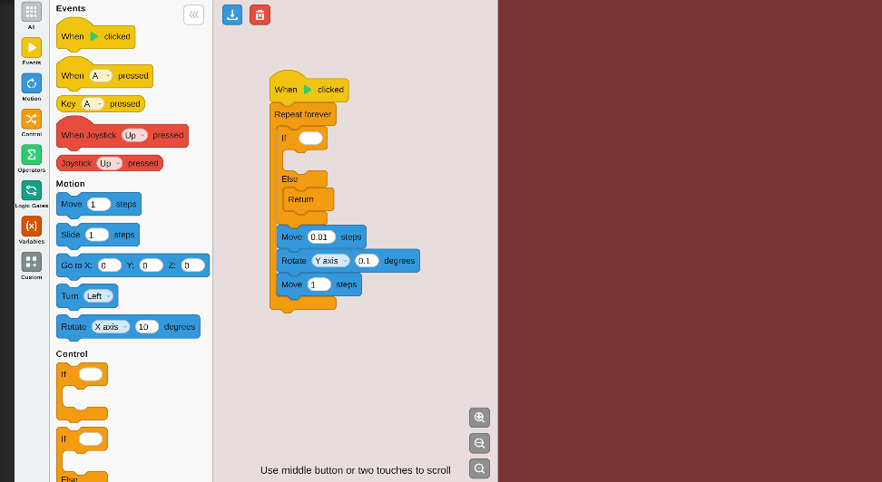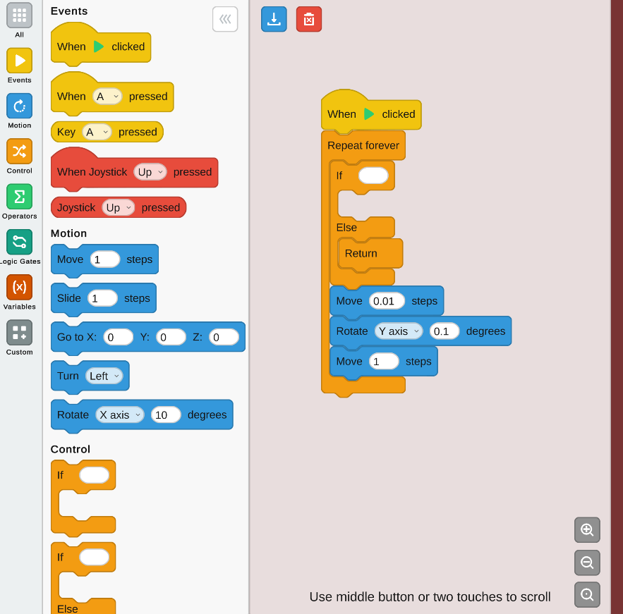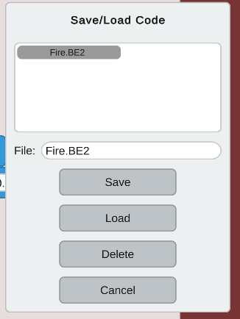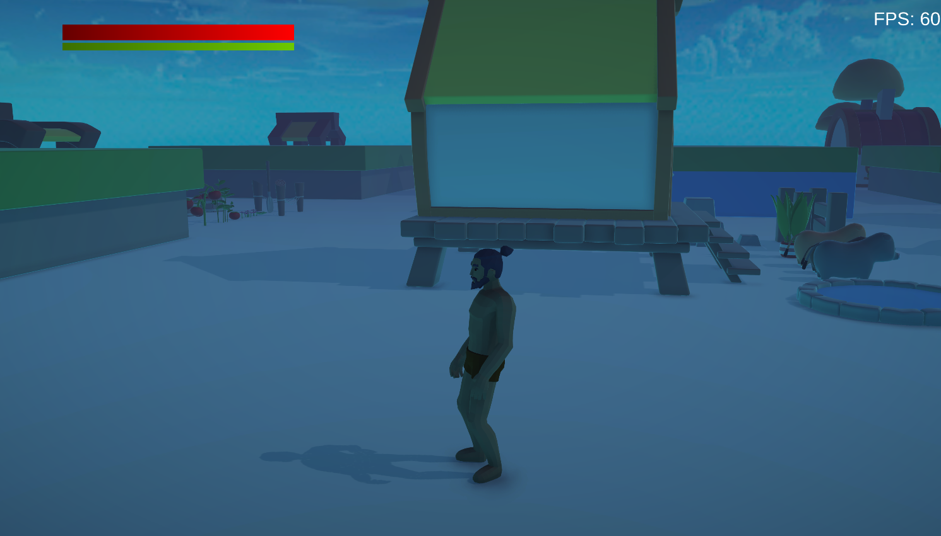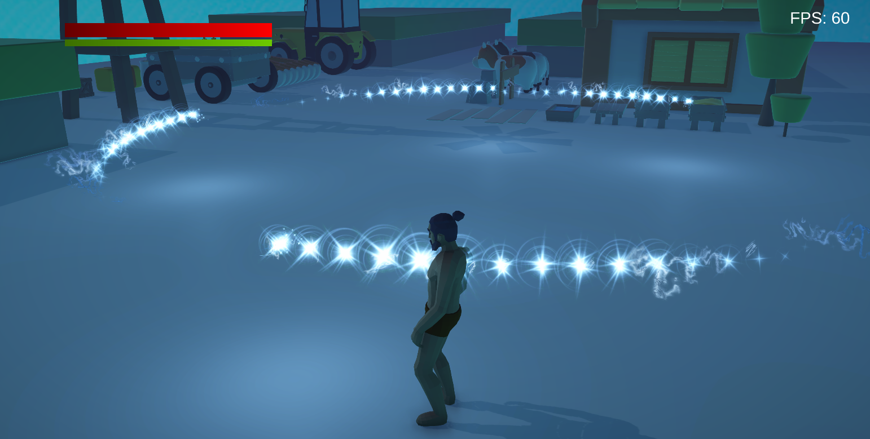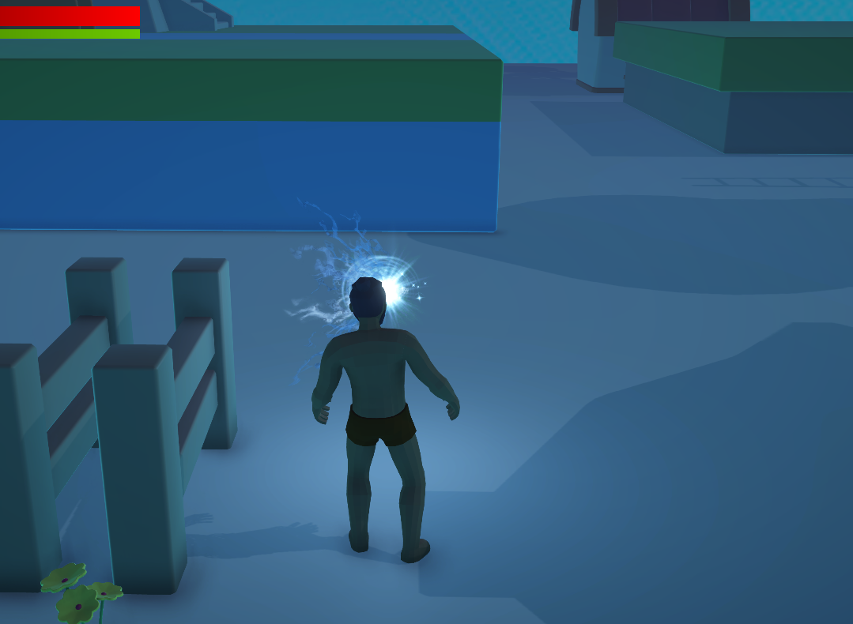

RESEARCH PAPER

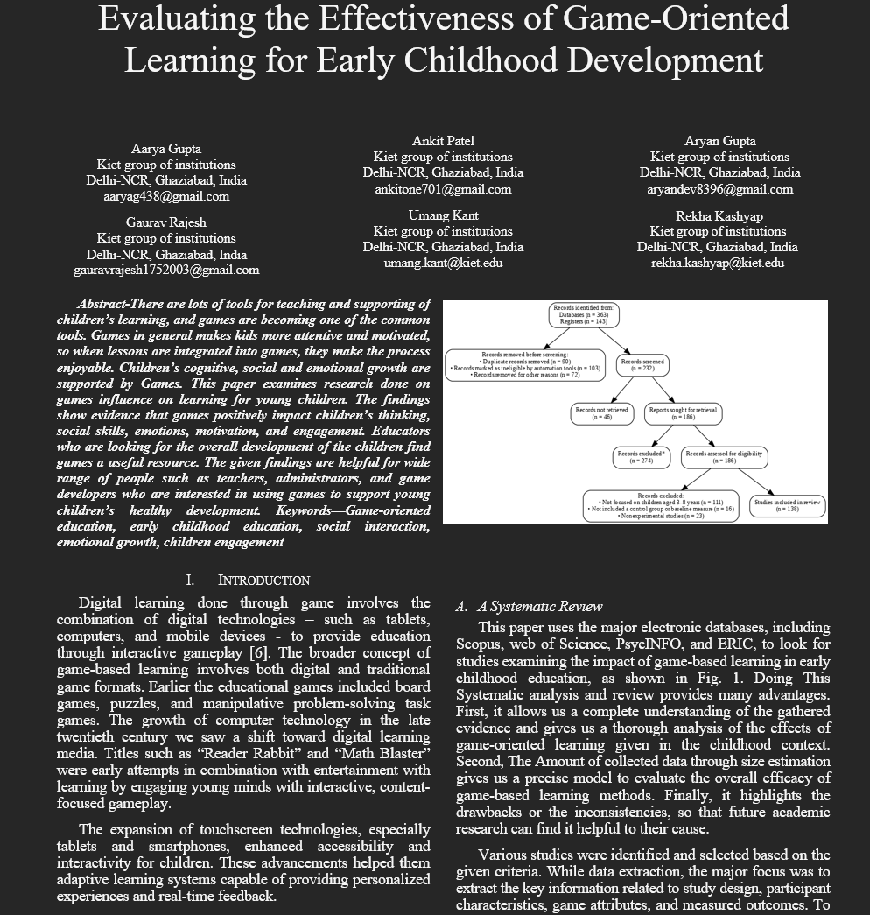
PLAGIARISM REPORT
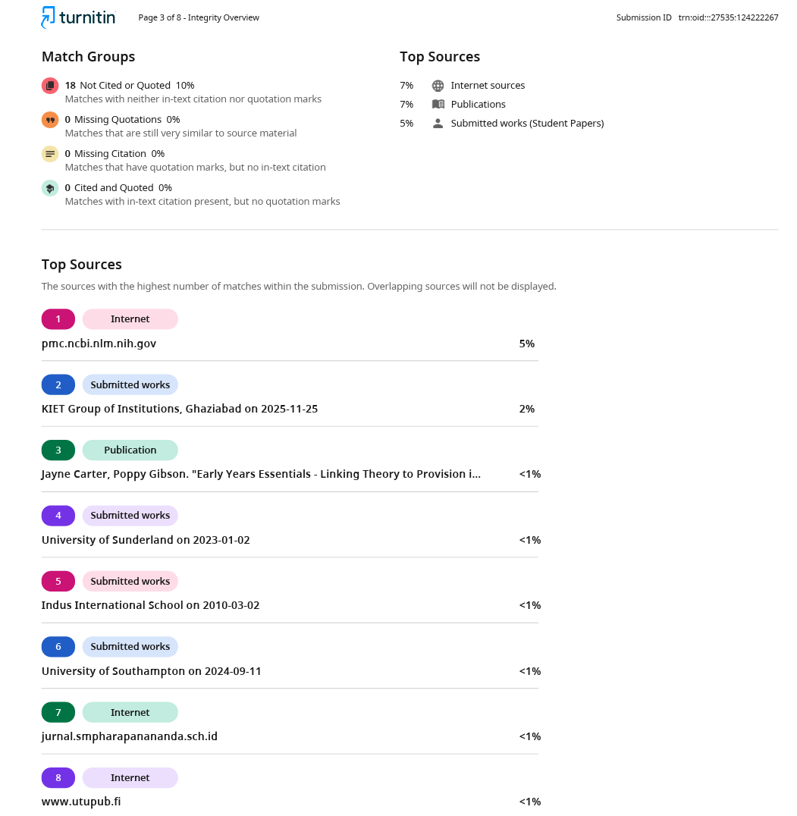

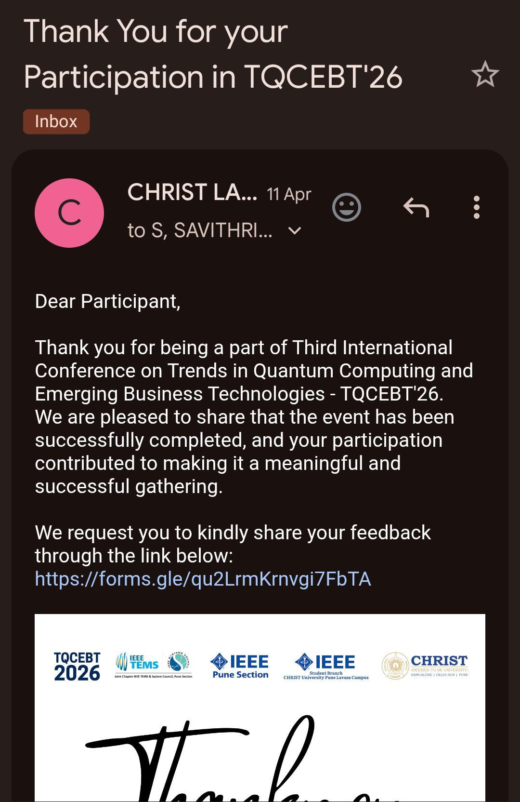w

